**802.11AC WiFi5 1200M Wireless Router**

ND-WR1200E

1. Overview

Newbridge®ND-WR1200E is a new generation high-performance enterprise-level dual-band 1200M router that supports HW-NAT and 802.11ac technology. It achieves an Internet NAT forwarding speed of up to 900+Mbps. The 5.8G band provides a maximum access rate of 866.7Mbps, while the 2.4G band provides a maximum access rate of 300Mbps, meeting the demand for high-speed wireless internet access for up to 64 terminals simultaneously. It features gigabit network interfaces and wireless access speeds of 300Mbps for 2.4G 802.11b/g/n and 866.7Mbps for 5.8G 802.11a/n/ac. It is plug-and-play and offers high performance, high gain, high receive sensitivity, high bandwidth, and high access capacity. It not only provides a wider coverage range, but also delivers higher wireless transmission performance and stability, making it the ideal choice for high-density environments such as education, government, enterprise offices, hospitals, and conference halls.

2. Product Image

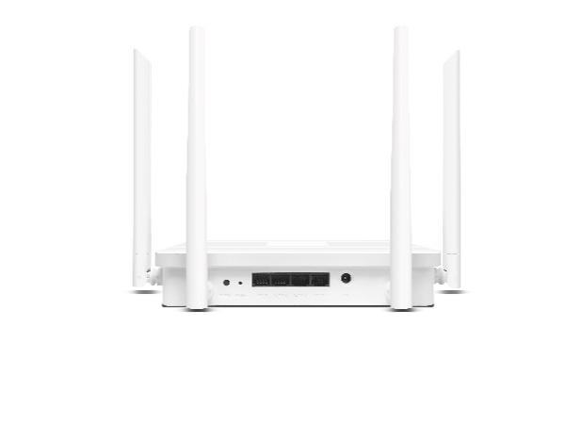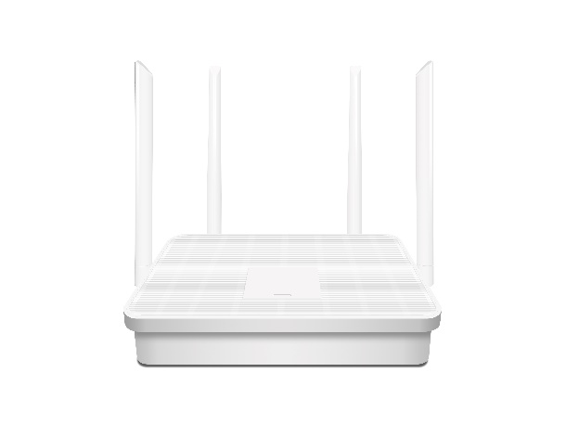

3. Product Features

* Designed based on operator-standard hardware, the anti-electromagnetic interference capability complies with the requirements of YD/T 968-2010 'Electromagnetic Compatibility Requirements and Measurement Methods for Telecommunication Terminal Equipment'. The overvoltage and overcurrent protection meets the requirements of YD/T 993-2006 'Technical Requirements and Test Methods for Lightning Protection of Telecommunication Terminal Equipment' for analog lightning surge, power line induction, power line contact, and other indicators, with a protective capability of 6KV common mode and 1.5KV differential mode. The anti-surge capability meets the requirements of YD/T 1082-2011 'Technical Requirements and Test Methods for Overvoltage and Overcurrent Protection and Basic Environmental Adaptability of Access Network Equipment'. Enhanced heat sink and optimized air duct design ensure stable operation even in hot summer days, effectively guaranteeing real-time, long-term, stable, and high-efficiency transmission of user network data, thus improving user experience.
* Supports 802.11b/g/n/ac protocols, providing wireless access speeds of 2.4G 300Mbps + 5G 866.7Mbps, and a total wireless access speed of 1200Mbps
* Gigabit Ethernet ports provide HNAT hardware acceleration for fast forwarding, with WAN port NAT performance reaching 900+Mbps
* Supports various network functions including routing mode, bridge mode, IPV4/IPV6, IPTV, relay, DDNS, VPN client, port forwarding/DMZ, and traffic control, easily adapting to various complex network scenarios
* Provides security protection such as WPS, WPA/WPA2, SSID hiding, guest network, MAC filtering, IP filtering, URL control, and anti-DDoS attacks, ensuring data security at all times
* Built-in quick setup wizard allows easy WiFi internet access without requiring professional knowledge
* Continuous product updates, feature enhancements, and performance optimizations ensure adaptability to various network environments, enhancing user experience

4. Specifications

|  |  |
| --- | --- |
| Hardware configuration | |
| Main Chip | SF19A2890 |
| Frequency | MIPS architecture, dual-core quad-thread 1GHz CPU |
| Memory | 128MB |
| Flash | 16MB |
| Wireless Technology | 2.4G: 300Mbps with 802.11b/g/n MIMO technology  5.8G: 866.7Mbps with 802.11a/n/ac MIMO technology |
| Device Interfaces | WAN1/LAN3 10/100/1000Mbps adaptive Ethernet ports  DC power interface, compatible with power plugs with an outer diameter of 5.5mm, inner diameter of 2.1mm, and length of 9.5mm or above |
| Buttons | Reset button for restoring factory settings, long press for 6 seconds to restore factory settings  WPS button for easy password-free connection |
| Indicators | Status indicator lights |
| Antennas | External 2.4G 5dBi stick antennas *2  External 5G 5dBi stick antennas *2 |
| Power | DC 12V/1A power supply with positive outside and  negative inside |
| Operating/Storage Temperature | 0℃～40℃/-20℃～70℃ |
| Operating/Storage Humidity | 10% to 90% (non-condensing) / 5% to 90% (non-condensing) |
| Dimensions | 20*12.5*3.6CM(Excluding antennas) |
| Weight | 0.25KG |
| WiFi Spec | |
| Frequency Range | 2.4G：2.4~2.4835GHz  5G: UNII-1: 5.15~5.35GHz  UNII-2: 5.47~5.725GHz  UNII-3: 5.725~5.825GHz |
| Channel | 2.4G: 1、2、3、4、5、6、7、8、9、10、11、12、13  5G: 36、40、44、48、52、60、64、149、153、157、161、165 |
| Modulation | 802.11b: DSSS (DQPSK, DBPSK, CCK)  802.11g: OFDM (BPSK, QPSK,16-QAM)  802.11n: OFDM (BPSK, QPSK,16-QAM, 64-QAM)  802.11ac: OFDM (BPSK, QPSK,64-QAM, 256-QAM) |
| Transmission Rate | 11b up 11Mbps，11g up 54Mbps，11n up 300Mbps  11ac up 864.7Mbps |
| Receiver  Sensitivity | 2.4G:  11b：＜-82±1.5dBm @1Mbps，  ＜-76±1.5dBm dBm@11Mbps  11g：＜-82±1.5dBm@6Mbps，  ＜-65±1.5dBm @54Mbps  11n 20MHz：＜-82±1.5dBm@MCS0，  ＜-64±1.5dBm @MCS7  11n 40MHz：＜-79±1.5dBm @MCS0，  ＜-61±1.5dBm @MCS7  5G:  11a：＜-82±1.5dBm @6Mbps，  ＜-65±1.5dBm @54Mbps  11n 20MHz：＜-82±1.5dBm@MCS0，  ＜-64±1.5dBm @MCS7  11n 40MHz：＜-79±1.5dBm @MCS0，  ＜-61±1.5dBm @MCS7  11ac 20MHz：＜-82±1.5dBm @MCS0，  ＜-57±1.5dBm @MCS8  11ac 40MHz：＜-79±1.5dBm @MCS0，  ＜-54±1.5dBm @MCS9  11ac 80MHz：＜-76±1.5dBm @MCS0，  ＜-51±1.5dBm @MCS9 |
| Transmit Power | 11b: 20dBm±1.5dBm@11Mbps  11g: 20dBm±1.5dBm@54Mbps  11n(20/40MHz): 17dBm±1.5dBm@MCS7  11ac(40/80MHz): 17dBm±1.5dBm@MCS9 |
| Software Functions | |
| Working Mode | Routing mode/Bridge mode |
| Number of  connected users | 64 Peoples |
| Management mode | English web remote management/support for TR069 remote management |
| Status | Internet\Router\WiFi\Primary Network User\  Guest User\DHCP List |
| Network | Ethernet：Network (Routing\Bridge) \  Ethernet Setting (Dynamic IP\Static IP\PPPoE)\  Ethernet Status  LAN Setup:  Lan: IP Address\Subnet Mask\DHCP setting\DNS\  Lease time  Guest Network Address Pool |
| Wireless | -WiFi: Dual frequency in one\2.4G&5G WPS switch\  2.4G&5G: Status switch\Hide SSID\SSID\Security\  Encryption Mode\Password\  Advanced Settings: Protocol\Channel Bandwidth\  Channel\Tx power  -Black and White List: Switch\  Mode switch (Blacklist\Whitelist) \Blacklist  -WPS: 2.4G&5G Switch\PBC  -Mesh: Switch\Role (Automatic\Main route\Satellite) \  Add satellite\Fast roaming\  2.4G&5G Set signal strength threshold  -Relay mode: Switch\Frequency band\SSID(Scan)\  Security\Password\Status |
| Network Advanced | IPV6\DDNS\IPTV\Guest Network\Parental Control\  VPN Client(PPTP\L2TP)\Hardware HNAT |
| Firewall | Port Forwarding\DMZ Settings\MAC Filtering\  IP Filtering\DDOS\URL Control |
| Management | SNTP, Traffic control, Change password,  Backup/Upgrade, Restart/Reset, LED switch, Logs |
| Setup Wizard | WiFi-Network Configuration-Summary |

5. Product dimension diagram(cm)

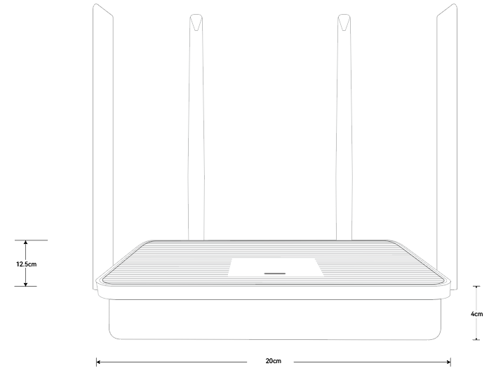

Order Information

|  |  |  |
| --- | --- | --- |
| **Part No** | **Description of product** | **Unit** |
| ND-WR1200E | 802.11AC WiFi5 1200M Wireless Router | pc |