



30W International Standard PD

802.3AF/AT 12V 2A Isolated Type

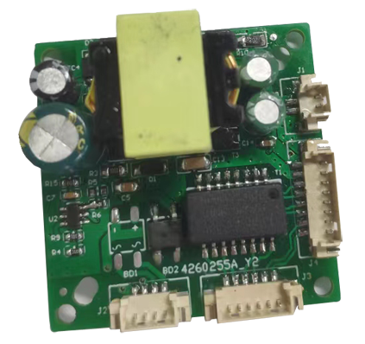

一、Feature：
ND-PD3824 is a high performance POE module with photoelectric isolation,comply with IEEE 802.3AF/AT standard, the size is 38*38*15mm.The output power can meet more than 99% of the market demand for camera power consumption.
•ND-PD3824 can be easily matched with more than 99% of the modules on the market, such as XM, HIKVISION, Dahua and many other IPC module manufacturers.
• Adopt high-end POE chip design, with isolation transformer and a variety of protection circuits.
• POE protocol: IEEE802.3af/at
• POE Power: Full 24W, continuous work for long time,very reliable power ,DC(OUT):12V/2A, 4-layer PCB design, continuous low operating temperature
• Isolation voltage: 1500V
• POE transmission: 1,2+/3,6- and 4,5+/7,8- adaptive

二、Electrical parameter ：

Voltage Typr | PoE switch input 48V
Paramater | minimum | Rated Value | Maximum
input | 42Vdc | 48Vdc | 56Vdc
output | 11.5V | 12V | 12.5V
Input current | 0.03A | 2A | 2.4A
mVpk=pk | 200mV Max
Efficiency | Beyond 80%
Short-circuit protection | When the output is short-circuited to the ground, the input power of the product is reduced and will not be damaged. When the short-circuit situation is removed, the product will automatically return to normal

三、PIN defined description:
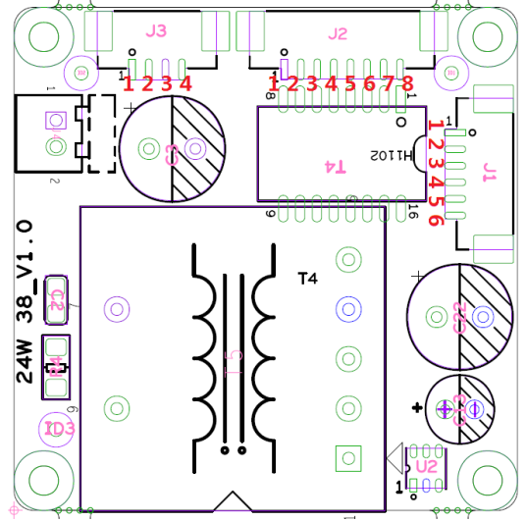
PIN | Definition |  | remarks
J3 | 1 | DC+ | PoE switch input 45V
J3 | 2 | DC- | PoE Switch input 78V
J3 | 3 | GND | 12V output
J3 | 4 | +12V | 12V output
J2 | 1 | GND | 12V output
J2 | 2 | +12V | 12V output
J2 | 3 | TX+ | switch data output P1
J2 | 4 | TX- | switch data output P2
J2 | 5 | RX+ | switch data output P3
J2 | 6 | RX- | switch data output P6
J2 | 7 | LED+ | External indicator light is connected to entrance
J2 | 8 | LED- | External indicator light is connected to entrance
J1 | 1 | LED- | Camera indicator light signal port
J1 | 2 | LED+ | Camera indicator light signal port
J1 | 3 | RX- | switch data input P6
J1 | 4 | RX+ | switch data input P3
J1 | 5 | TX- | switch data input P2
J1 | 6 | TX+ | switch data input P1

四、Environmental/humidity requirements：
Operating temperature and humidity requirements

For altitudes less than or equal to 10,000 feet, low temperature operating limit is -25 ° C, high temperature operating limit is +85 ° C, and relative humidity is 20%RH to 80%RH.
• Storage temperature and humidity requirements
Low temperature storage minimum of -30 ° C (ice-free environment) at altitudes below 30,000 ft.The upper limit of high temperature storage is +80℃, and the relative humidity is 10%RH ~ 90%RH

