**FEATURES**

* 10/100/1000M smart media converter
* 1*1000M optical port ,1*10/100/1000M RJ45
* 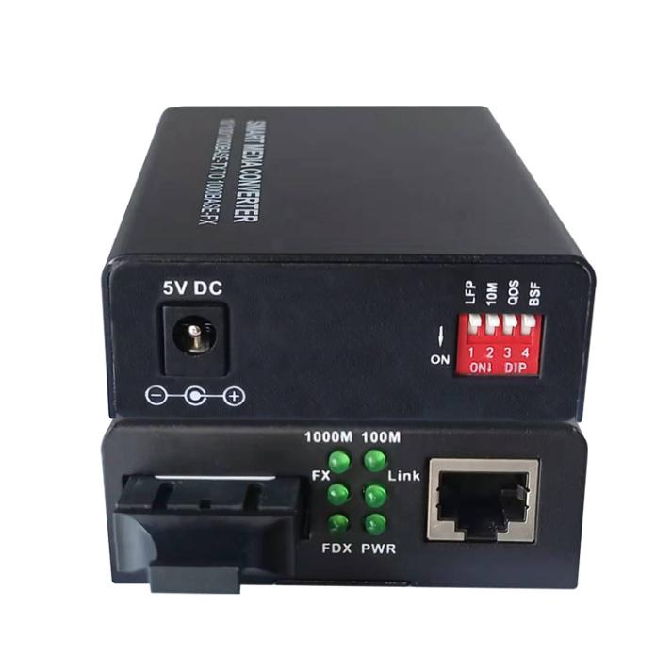1000M Dual fiber Singlemode,1310nm,SC, 0~20KM
* Support LFP function, Auto MDI / MDI X
* LFP (Link Fault Pass-Through) for indication of a link failure on the transmitting path of the FX receiving circuitry.
* Supporting Far End Fault function on FX port
* Supporting Transparent to 802.1Q VLAN tagged packets
* Supporting the transmission of extra-long packets up to 1600 bytes
* Supporting store and forward mode / transparent transfer mode selectable by DIP switch
* Provides user accessible settings for TP port configuration, disabling link fault pass-through function
* Extremely low power consumption (less than 2W), low heat, reliable quality, stable performance, and long lifetime

**Newbridge®**10/100/1000M media converter with external power supply are designed to transmit and receive 10/100/1000Mbps data over optical fiber. The electrical interface will Auto-Negotiate to a 1000Mbps or 1000Mbps Ethernet rate without any adjustments. The optical interface operates at a 1000Mbps Ethernet rate. Both are environmentally hardened to operate in extreme temperatures. LED indicators are provided for confirming equipment operating status.

16-Pot 10/100Mbps +2G TP/SFP Combo

PoE Switch with LCD Display

**Specially:**This equipment also supports fixed 1000M ethernet rate with the DIP switch

Specifications

|  |  |
| --- | --- |
| **Parameters** | **Specifications** |
| Standards | IEEE 802.3 10Base-T IEEE 802.3u 100Base-TX IEEE 802.3ab 1000Base-TX/FX |
| Transmission Distance | 1000M Dual fiber Singlemode,1310nm,SC,  0~20KM,Stand alone |
| Port | 1* 1000M optical port ,1*10/100/1000M RJ45 |
| MDI/MDI-X | Support LFP function, Auto MDI / MDI X |
| Mac address table | 4K |
| Memory buffer | 256K |
| Forward / Filter Rate | 10M: 14,880/14,880pps  100M: 148,800/148,800pps 1000M: 1,488,000/1,488,000pps |
| Power Supply | External : 5V DC 1A/2A  Built-in: 90 V to 240 V AC 50Hz to 60 Hz  Power Consumption : ≤5W |
| Operating Temperature | 0 °C to +65 °C |
| Storage Temperature | -20 °C to +65 °C |
| Relative Humidity | 5% to 90% (non-condensing) |
| Dimensions | 95mm * 70 mm * 25mm |

**☞**DIP SWITCH

*Toggle ON pin 1 to LFP is enable; OFF is disable

*Toggle ON pin 2 to Store and forward switch is enablel;OFF pin 2 to Modified cut-through switch mode is enable

*Toggle ON pin 3 to auto-negotiation mode is enable;OFF pin 3 to force the TX port work 10/100/1000Mbps,full/ half duplex

*Toggle ON pin 4 to TX is work 10Mbps, OFF is 1000Mbps

Application Diagram

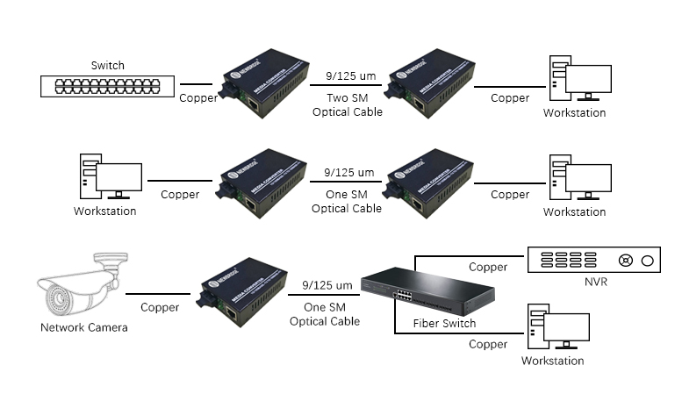

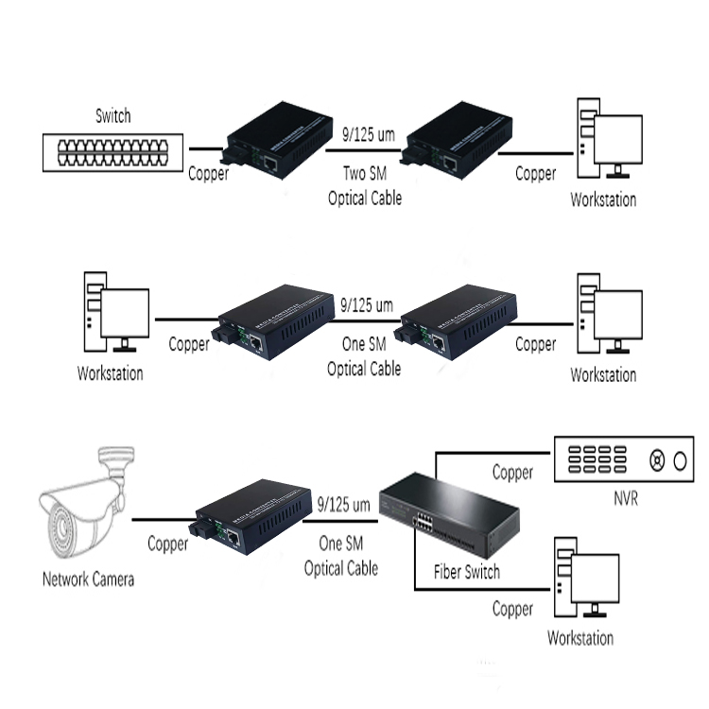

Order Information

|  |  |  |
| --- | --- | --- |
| **Part No** | **Description of product** | **Unit** |
| ND-920SSW-20 | Dual fiber Single mode 1310nm，20km,SC,220V/AC,5V2A/DC,1*1000Base-Fx+1*10/100/1000Base-Tx | pc |